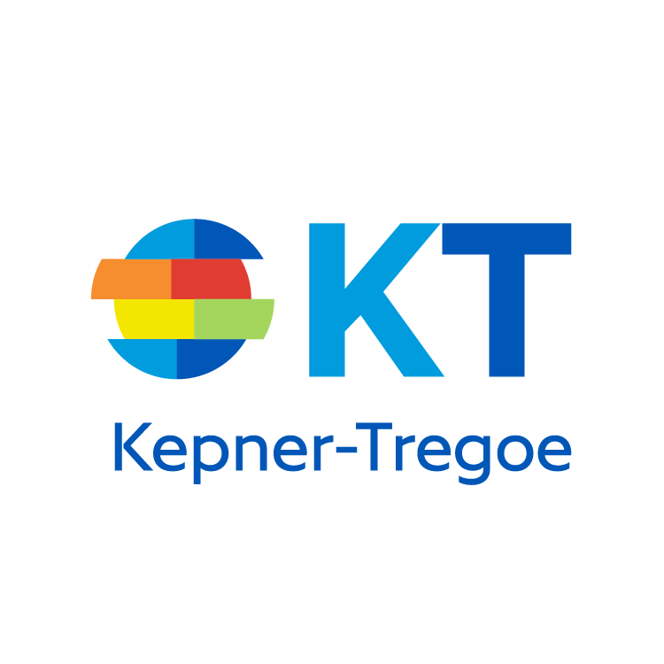

Thank you for planning to attend the upcoming KT Problem Management workshop. This prework has two purposes:
To provide an overview of key concepts and the objectives for the workshop.
To describe what you can do to prepare for the workshop.
I. SESSION DESCRIPTION
Kepner-Tregoe Clear Thinking processes provide a logical, systematic problem-solving methodology, including:
- Situation Appraisal is the first step in the troubleshooting process—surfacing, clarifying, prioritizing, and planning the resolution of complex customer issues and concerns.
- Problem Analysis is a proven approach to gathering, organizing, and analyzing the information required to find and confirm a problem’s root cause(s). To permanently correct a problem, action must be taken to address its root cause(s). A “problem” is defined as a deviation between what SHOULD be happening and what ACTUALLY is happening, for which you do not know the cause. This is illustrated with the following diagram:
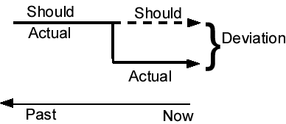

- Decision Analysis is a systematic process for making a choice. Decision Analysis provides a proven method to balance the benefits and risks of making a choice.
- Potential Problem Analysis is a systematic process for protecting actions or plans. Potential Problem Analysis provides a proven method to avoid reactive action.
The primary objective of this workshop is to incorporate a consistent, repeatable process throughout your organization’s problem resolution chain. You will also learn proven tools and techniques for the implementation of KT’s processes into an IT support organization to improve its performance.
II. PREPARATION
In order to participate more effectively in the workshop, read chapters 1 and 2 from The New Rational Manager. It can be downloaded using this link:
http://www.kepner-tregoe.com/training-workshops/prework/problemmanagementprework/

To maximize the value of the workshop, please read and thoughtfully respond to the following questions.
1. What are current examples where the processes described in Section I would apply? More specifically:
Situation Appraisal: Please provide two or three examples of current, complex customer issues (threats or opportunities) that require your direct involvement to resolve.

Problem Analysis: Please provide two or three examples of cause-unknown customer problems that you are either currently analyzing or will/should be in the near future.

2. From your perspective, what do you consider to be the characteristics or behaviors of an effective problem solver?

3. What do you see as current opportunities for improving problem solving within your organization?

To enable you to focus on the subject matter and actively participate in the Problem Management workshop, please arrange for coverage so you will not be distracted during the session. There will be breaks for phone calls, etc., but we need your attendance for the full period to maximize the positive impact of the KT processes on improving customer satisfaction, reducing average time to resolution, and improving other metrics.
III. SUMMARY
Thank you for taking the time to prepare for this workshop. Please bring this pre-workshop information with you. We look forward to your attendance and participation.

